**Spatial connectivity and temporal clustering**

Sidhan V V1, Manabendra Saharia1,2

1Department of Civil Engineering, Indian Institute of Technology Delhi, Hauz Khas, New Delhi 110016, India

2Yardi School of Artificial Intelligence, Indian Institute of Technology Delhi, Hauz Khas, New Delhi 110016, India

**Corresponding Author**:

Manabendra Saharia

Indian Institute of Technology Delhi

New Delhi, India 110016

Office: +91-011-26591260

Email: [msaharia@iitd.ac.in](mailto:msaharia@iitd.ac.in)

**Abstract**

**Key words:** Runoff Efficiency, ENSO, Indian Land Data Assimilation System, Spatio-temporal analysis

**Highlights**

1. **Introduction**

**1.1 First para**

Southern Asia has been experiencing the most severe dry-to-wet transitions and is projected to suffer more frequent, more intense, and accelerated dry-to-wet transitions (chen & Wang., 2022).

**1.2 Land-atmosphere interaction and river discharge**

Climate variability and anthropogenic regulations are two interwoven factors in the ecohydrologic system across large basins. Understanding the roles that these two factors play under various hydrologic conditions is of great signiﬁcance for basin hydrology and sustainable water utilization. In this study, we present an analytical approach based on coupling water balance method and Budyko hypothesis to derive effectiveness coefﬁcients (ECs) of climate change, as a way to disentangle contributions of it and human activities to the variability of river discharges under different hydro-transitional situations. The climate dominated streamﬂow change (DQ c) by EC approach was compared with those deduced by the elasticity method and sensitivity index. The results suggest that the EC approach is valid and applicable for hydrologic study at large basin scale. Analyses of various scenarios revealed that contributions of climate change and human activities to river discharge variation differed among the regions of the study area. Over the past several decades, climate change dominated hydro-transitions from dry to wet, while human activities played key roles in the reduction of streamﬂow during wet to dry periods. Remarkable decline of discharge in upstream was mainly due to human interventions, although climate contributed more to runoff increasing during dry periods in the semi-arid downstream. Induced effectiveness on streamﬂow changes indicated a contribution ratio of 49% for climate and 51% for human activities at the basin scale from 1956 to 2015. The mathematic derivation based simple approach, together with the case example of temporal segmentation and spatial zoning, could help people understand variation of river discharge with more details at a large basin scale under the background of climate change and human regulations."

### 1.3 Co-occurring events

**1.4 Climatic oscillations**

Flood clustering is typically explained by linkages between f lood frequency or magnitude and climate. There are well organized modes of inter-annual, inter-decadal and lower frequency climate variability (Barnston and Livezey, 1987). This variability may have a significant impact on the occurrence and magnitude of floods by changed atmospheric moisture uptake, transport and deposition

**Area to explore :**

* Study the regions of spatially co-occurring events at different time windows (3-4 years).
  + Co-occurring means one region there can be streamflow surplus while at the same time in another region, there can be surplus or deficit. Study such connections.
* Study the temporal connection (flood-drought transition or flood-flood transition ) *This can be other paper*
* Identify the time windows where there is maximum/ minimum connection or co-occurring events across stations.
* Investigate the lagged co-occurrences of events across station.

**1.3 Research Gap**

It is not yet well understood how spatial flood dependence, that is, the degree of co‐occurrence of floods at different locations, varies in space and time and which processes influence the strength of this dependence

**1.3 Objective**

* To identify regions with similar drought/ flood behaviour and analyse the physical processing governing their co-occurrence.
* Study spatial connectedness of precipitation and spatial connectedness of flood (Brunner et al., 2020) has shown that the spatial dependence of floods is not always higher than that of extreme precipitation. **The finding that spatial flood dependencies are governed by both spatial precipitation dependencies and land‐surface processes highlights the importance that these processes must be realistically represented in physical/hydrological models.**
* Study the temporal clustering of flood or drought event
* **Analyse flood rich/ drough rich periods and see if they are dependent on precipitation**
* **Is this drought/ flood rich period has any connectedness**

Rather than drought or flood, we are targeting the clustering of anomaly

1. **Study area**

The study area comprises of the South Asian landmass of India and its neighboring countries, spanning 64.5° E – 98° E and 5.5° N – 37.5° N. The Indian subcontinent consists of 18 major river basins consisting of 3 transboundary river basins - Indus, Ganga, and Brahmaputra. West Flowing Kachh Sabarmati is denoted as WFKS, and East Flowing rivers Mahanadi-Pennar, and East Flowing Pennar-Kanyakumari are together represented in the map as EEMP, and EFPK respectively.

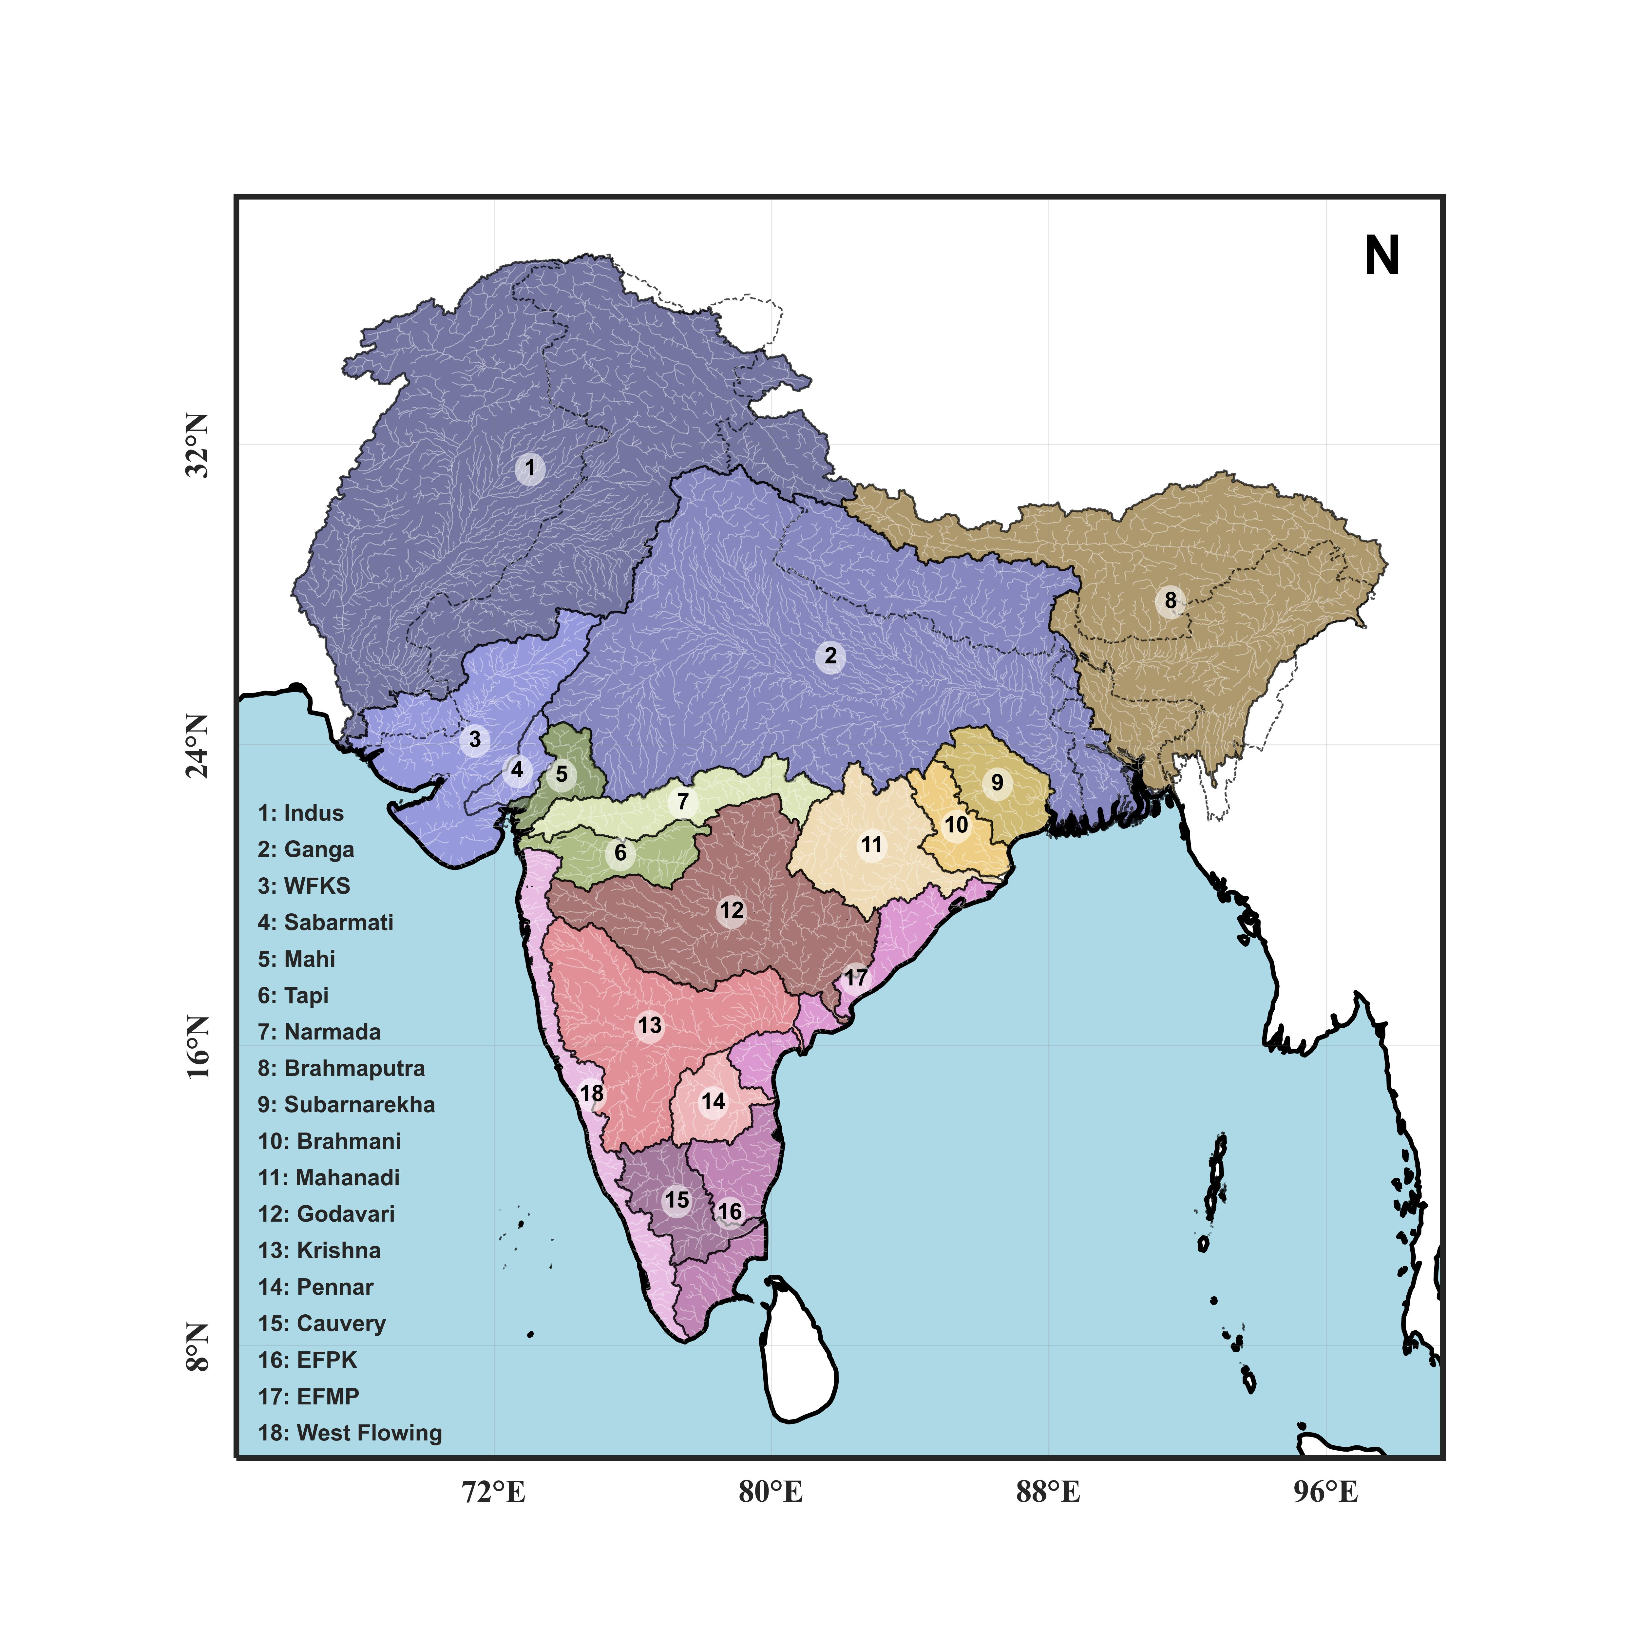

**Fig. 1** Study area showing various river basins of South Asia, including the transboundary extents of Indus (1), Ganga (2), and Brahmaputra (8).

1. **Data**
2. **Method**

***Cox regression***

*P(N = k) = \frac{\lambda^k e^{-\lambda}}{k!}*

1. **Possible claims**

**Possible claims:**

* We could show that when a drought is active in some region (A), there is more chances of occurrence of drought in region B.
* Also, the drought rich period and flood rich periods are active during some phases of climate oscillations.
* We could claim there occurs some de-coupling of spatial compounding events at certain regions from others.
* The drivers could be the ITCZ encroachment due to climate change, direction of wind etc
* The spatial dependency is greater in the winter season while it is lesser in winter

**Expected figures**

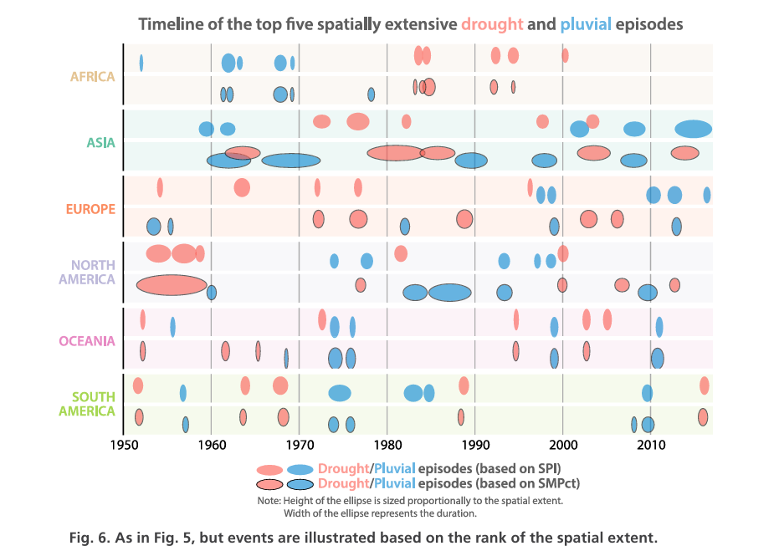

1. **Conclusions and Future Work**

**Acknowledgements**

The study was carried out in the IIT Delhi HydroSense lab (https://hydrosense.iitd.ac.in/), and the authors thank the IIT Delhi High Performance Computing facility for supplying the computational and storage resources. Dr. Manabendra Saharia expresses gratitude for grants that provided funding for this work such as ISRO Space Technology Cell (STC0374/RP04139); MoES Monsoon Mission III (RP04574); and DST IC-IMPACTS (RP04558). The authors would also like to thank Mr. Priyam Deka.

**Compliance with Ethical Standards**

The authors declare that none of the work reported in this study could have been influenced by any known competing financial interests or personal relationships.

**Author Contributions**

VVS: Conceptualization, Methodology, Formal analysis, Writing - Original Draft

MS: Conceptualization, Data Curation, Writing - Review & Editing

**Data Availability**

The following sources provide the datasets used in this study:

IMD precipitation: <https://www.imdpune.gov.in/Clim_Pred_LRF_New/>

Streamflow: Central Water Commission, India, and India WRIS, <https://indiawris.gov.in/wris/>

MERRA-2: GMAO, NASA Goddard Space Flight Centre, https://disc. gsfc.nasa.gov/datasets?project = MERRA-2.

MODIS Evapotranspiration: GSFC, NASA, https://modis.gsfc.nasa. gov/data/dataprod/mod16.php.

The data that support the findings are available on request from the corresponding author.

**References**

Brunner, M. I., Gilleland, E., Wood, A., Swain, D. L., & Clark, M. (2020). Spatial Dependence of Floods Shaped by Spatiotemporal Variations in Meteorological and Land‐Surface Processes. *Geophysical Research Letters*, *47*(13), e2020GL088000. https://doi.org/10.1029/2020GL088000